**Lambda Function**

**Step 1 – Create a EC2 Server.**

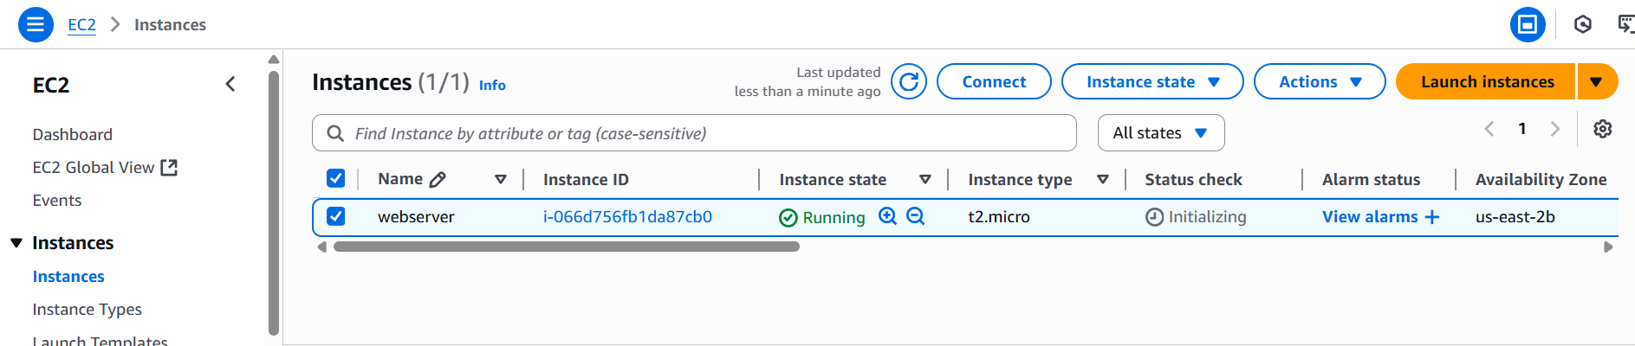

**Step2 – Create 1 role we need for lambda.**

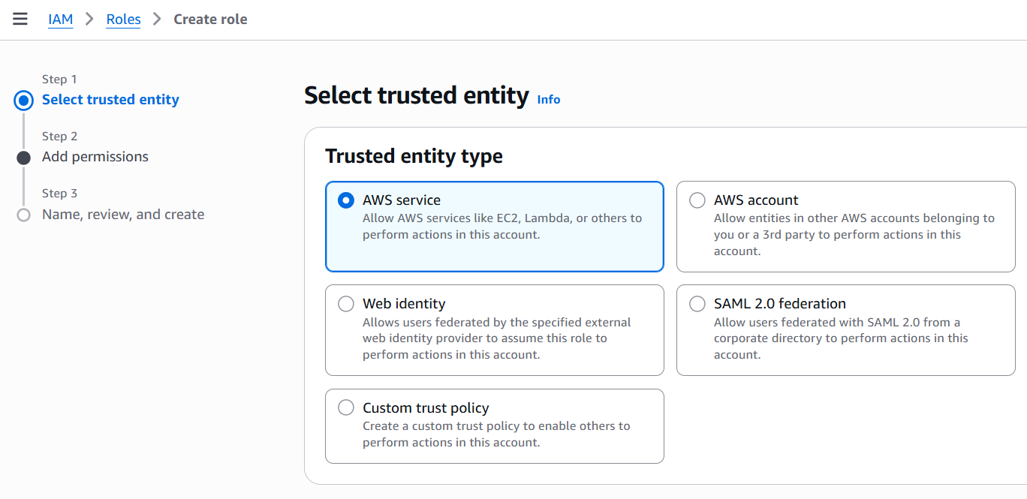

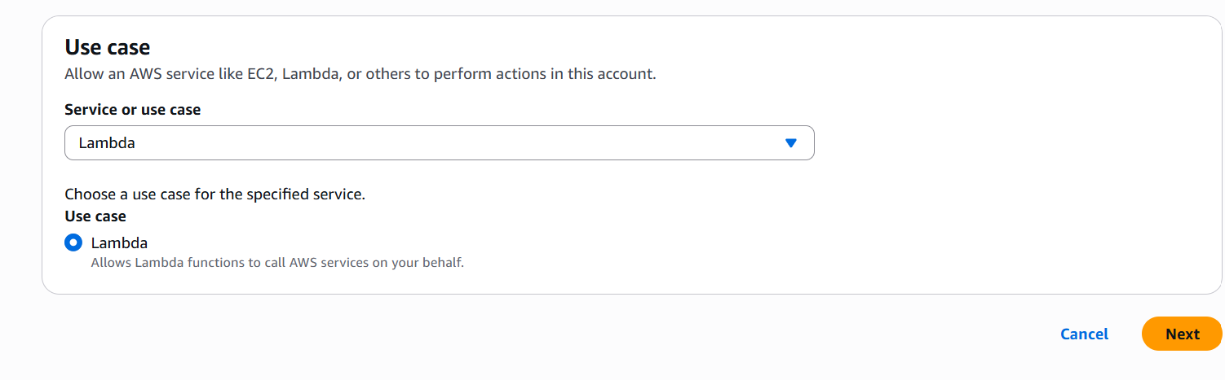

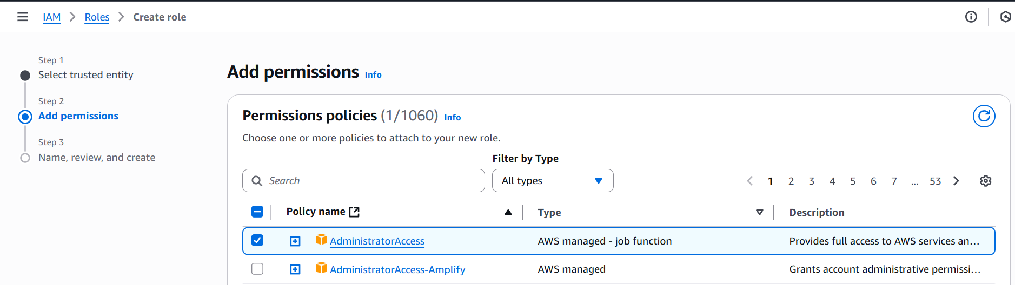

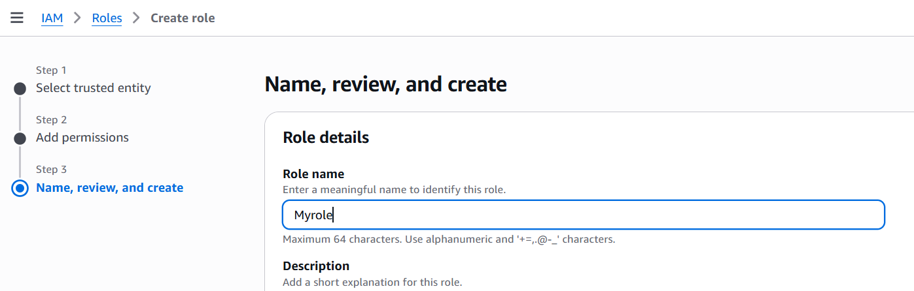

**Step 3 – Create a Lambda function.**

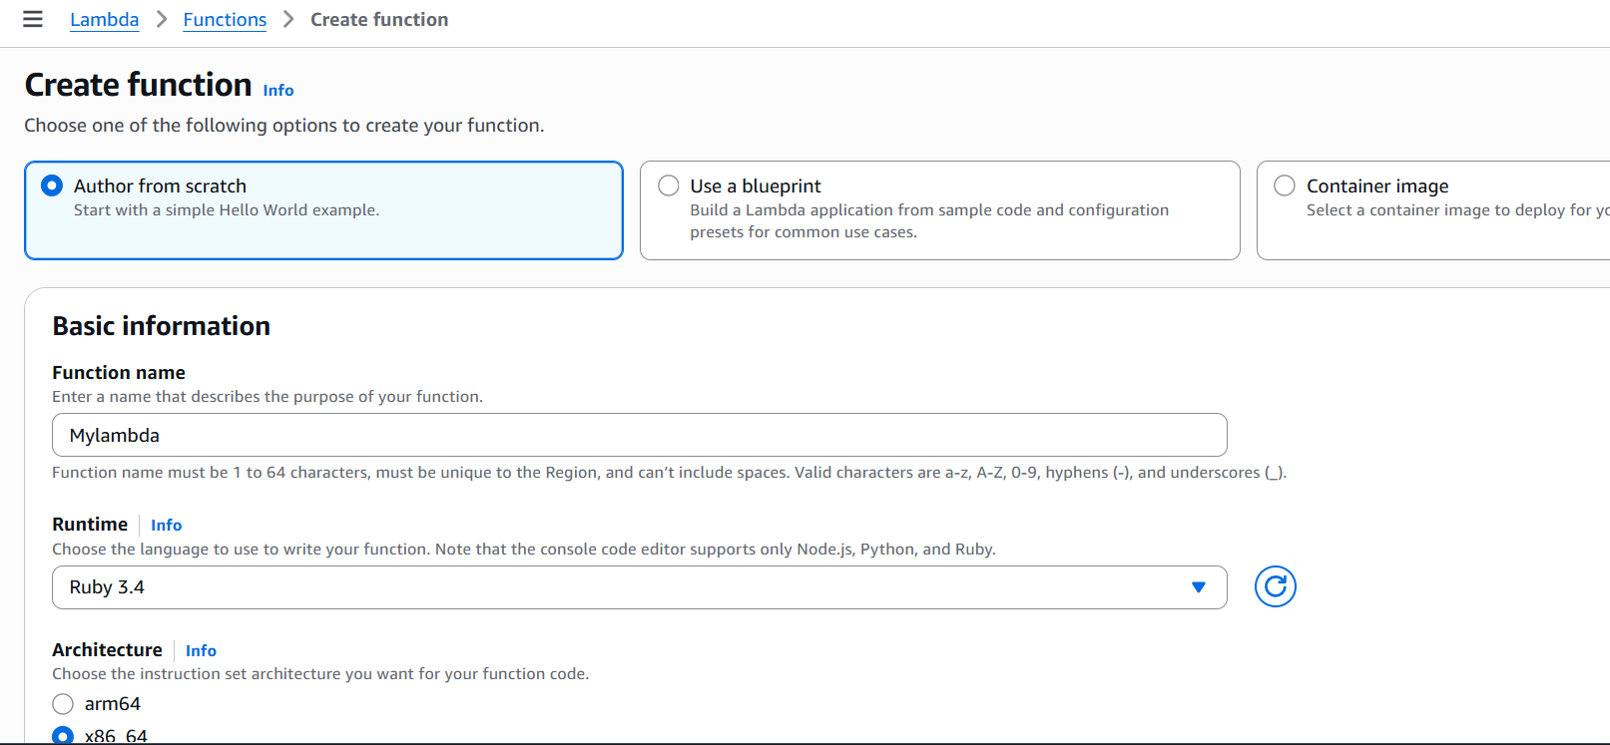

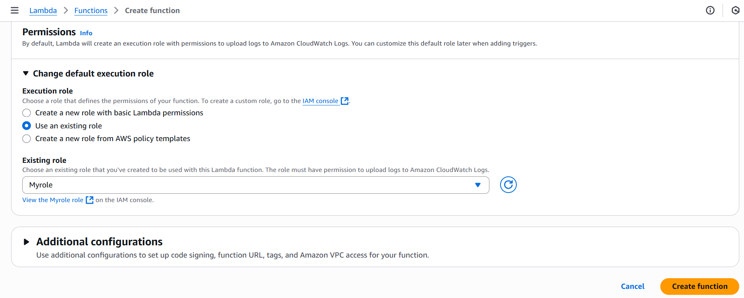

**Here under configuration, you can check storage, Ram & timeout.**

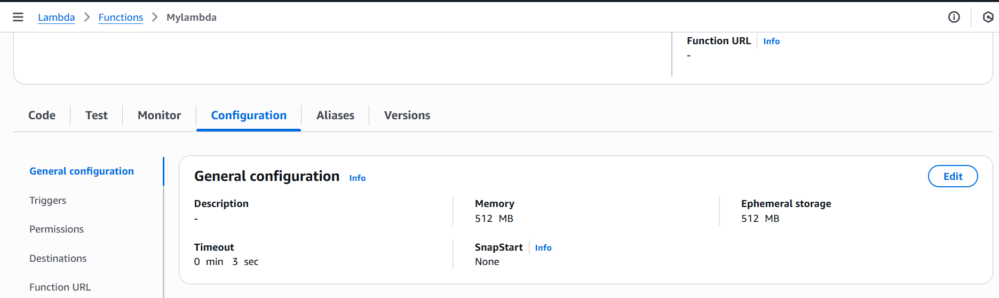

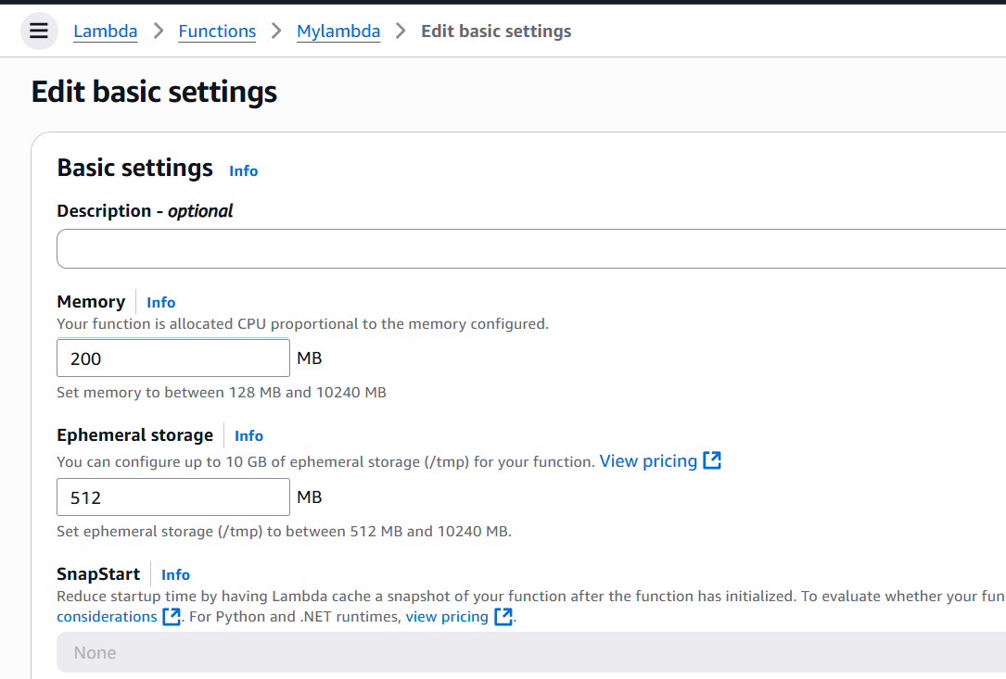

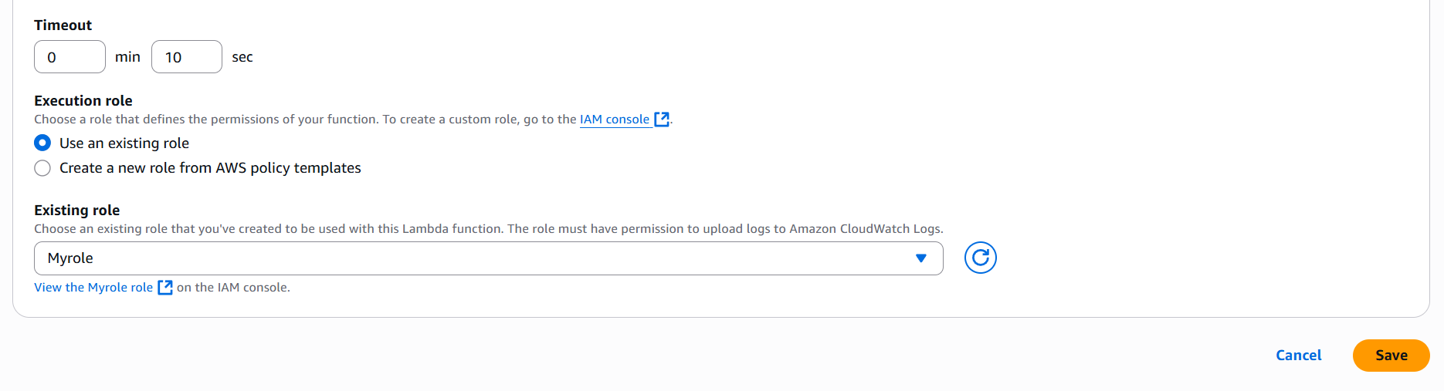

**In the code section need to upload a code.**

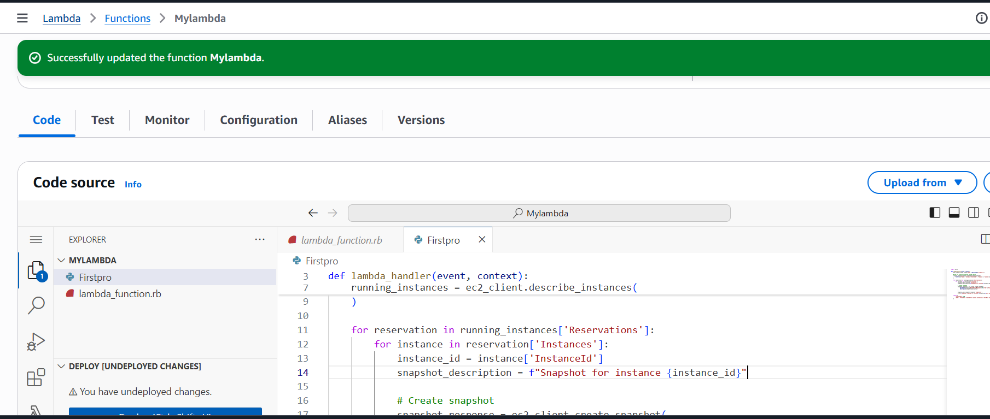

**Step 4 – Now create a Event bridge that helps to invoke lambda service while our instance is in stopped stage.**

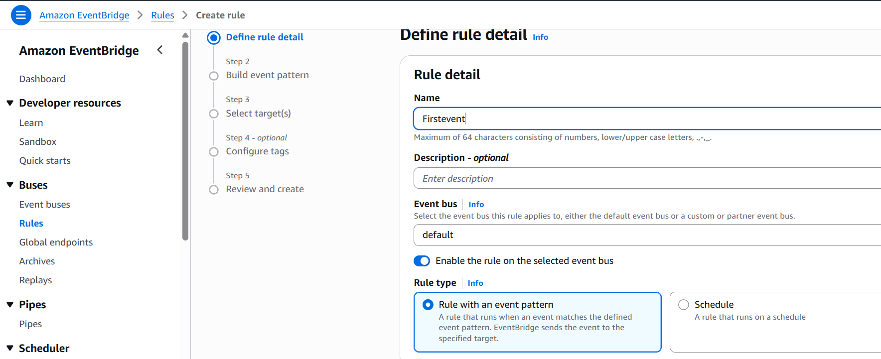

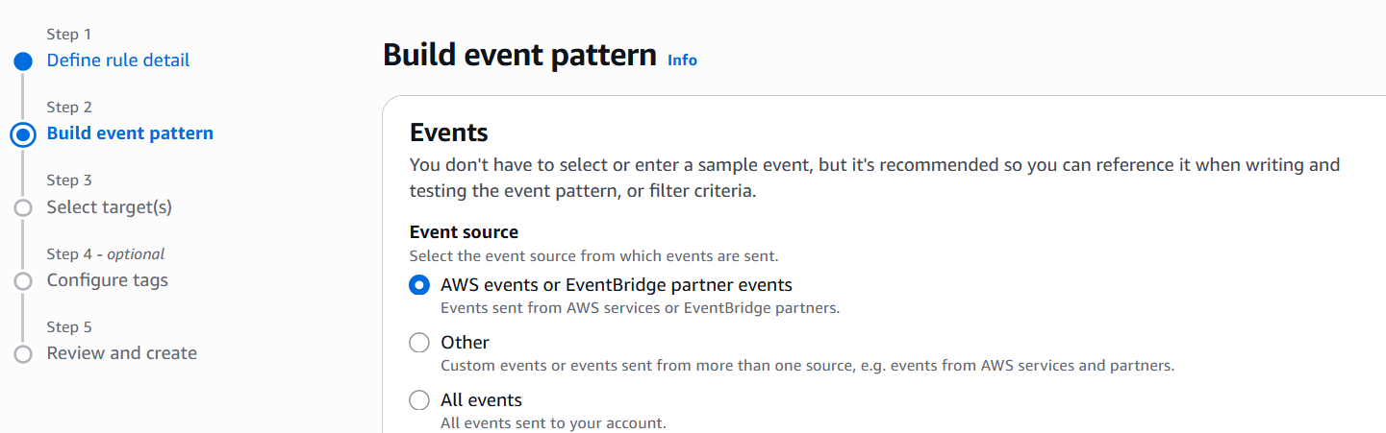

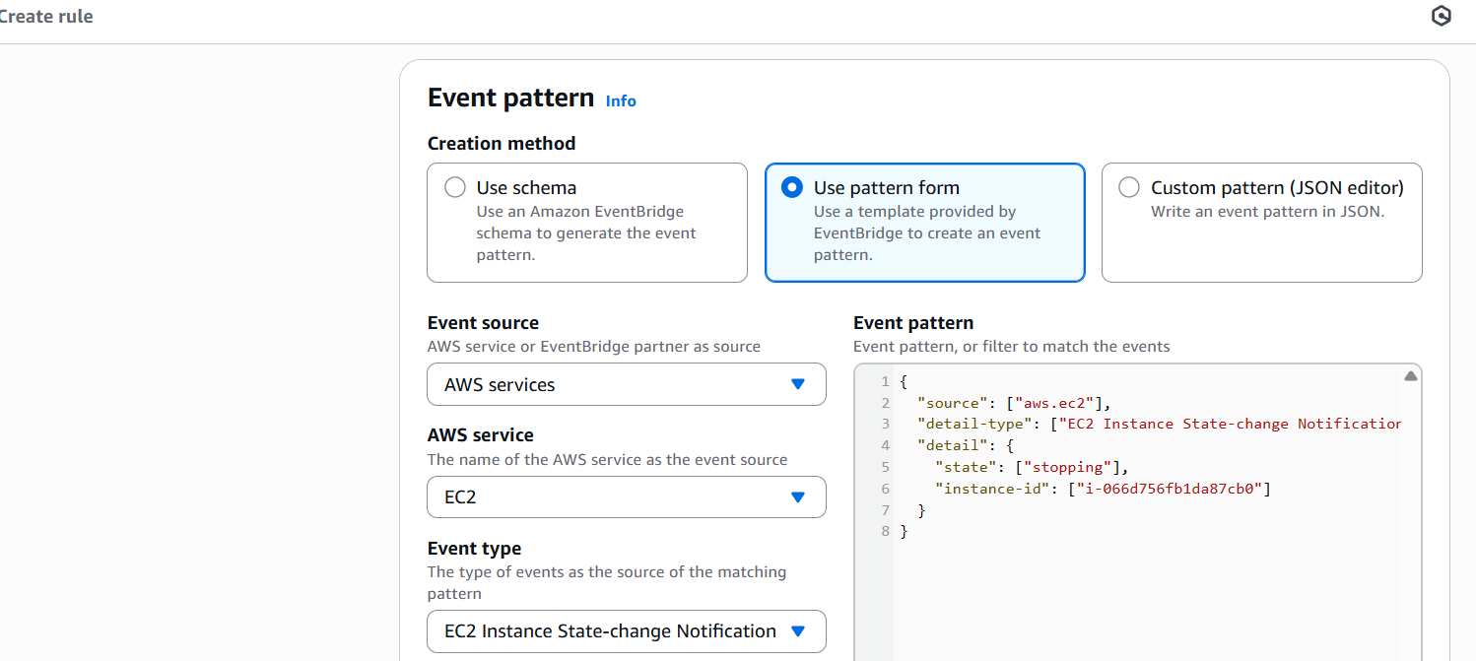

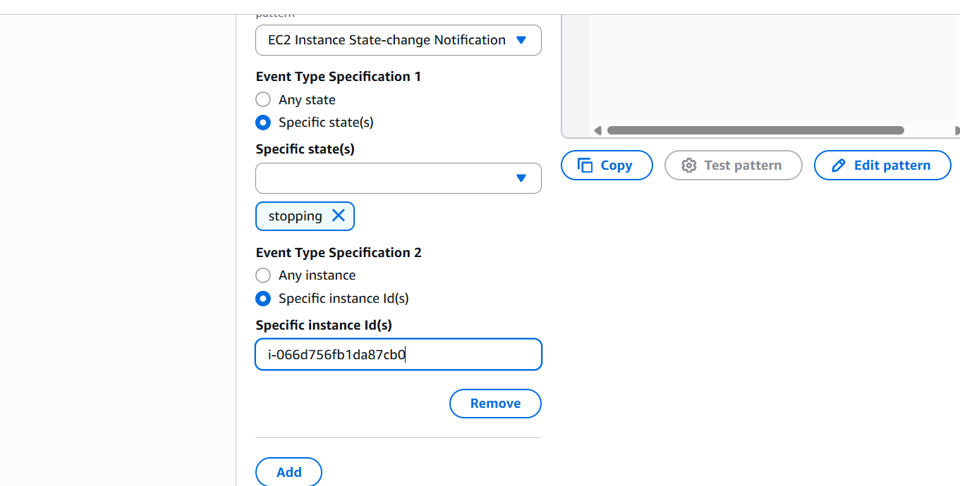

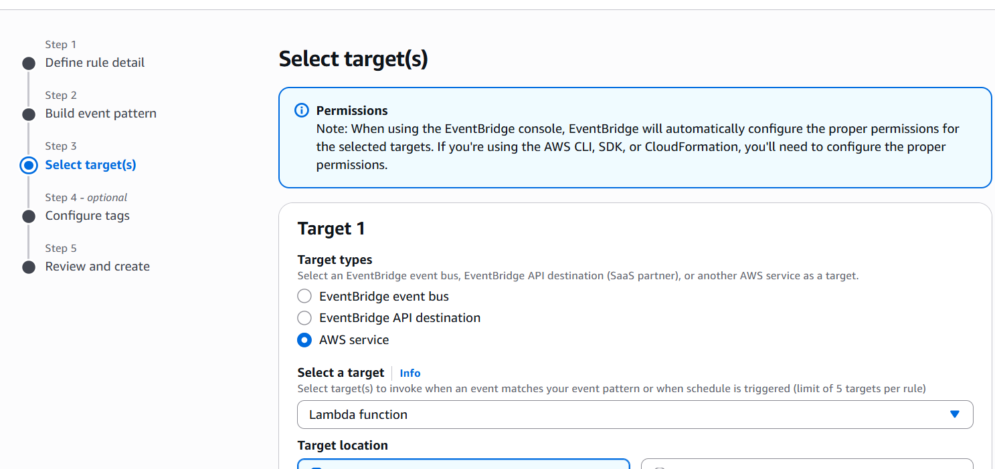

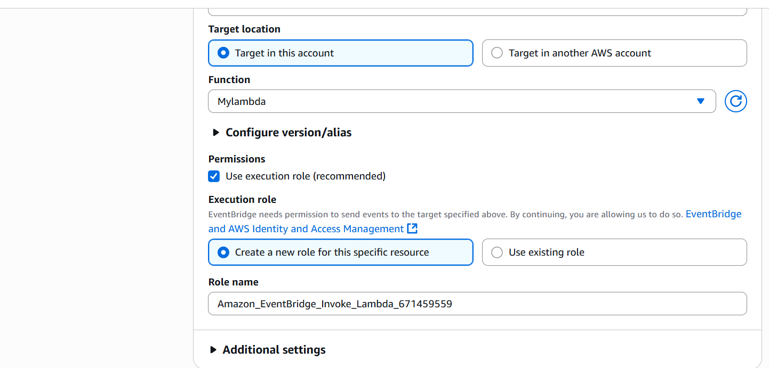

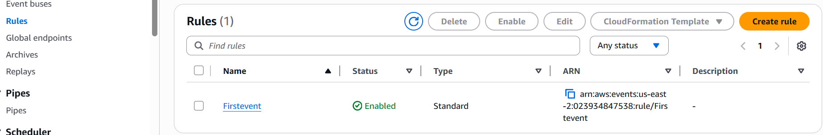

**Now come to lambda and deploy your code. Then stop your EC2 instance. Once instance in stopped condition 1 snapshot will generate.**

